Exercise 1, Part 7 – docker ps & docker log

Exercise 1, Part 7 – docker log cont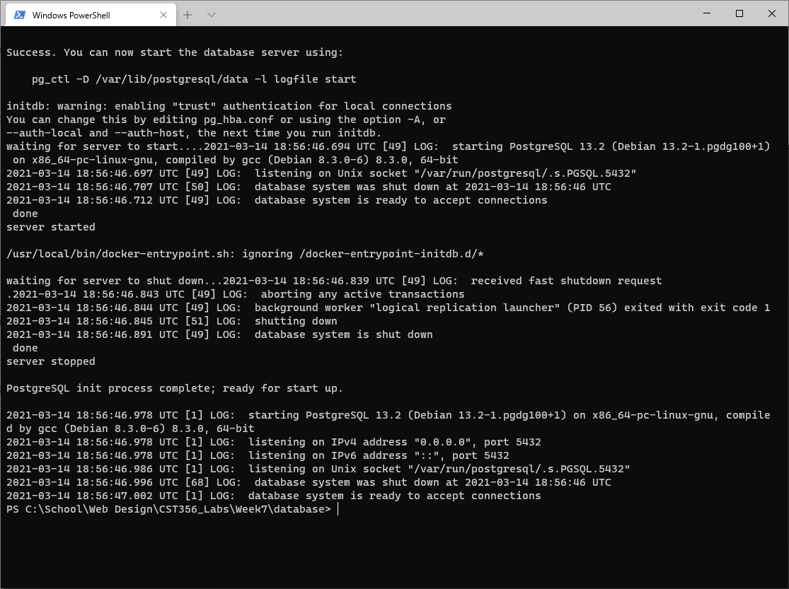

Exercise 1, Part 10 – pg Admin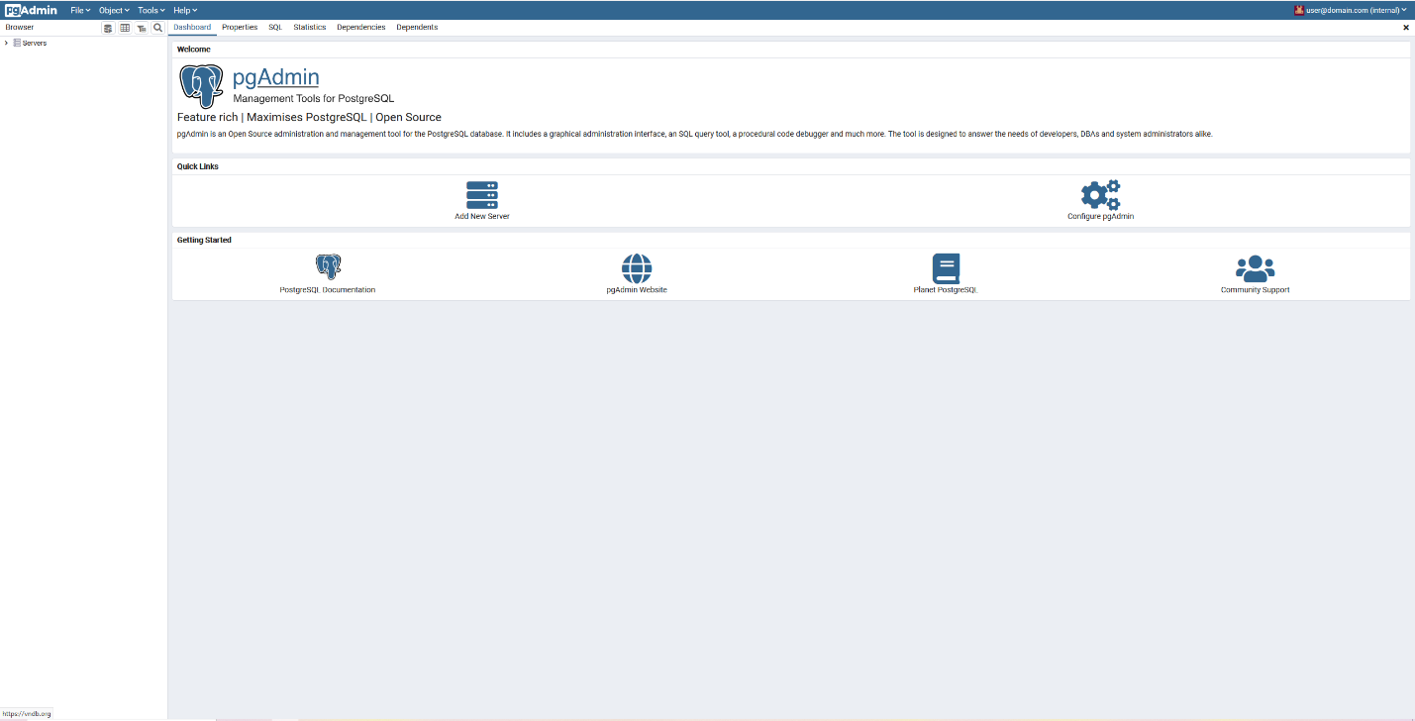

Exercise 2, Part 8 – Student data

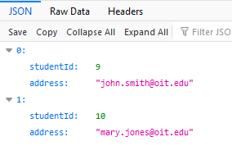

Exercise 4, part 7 – Docker build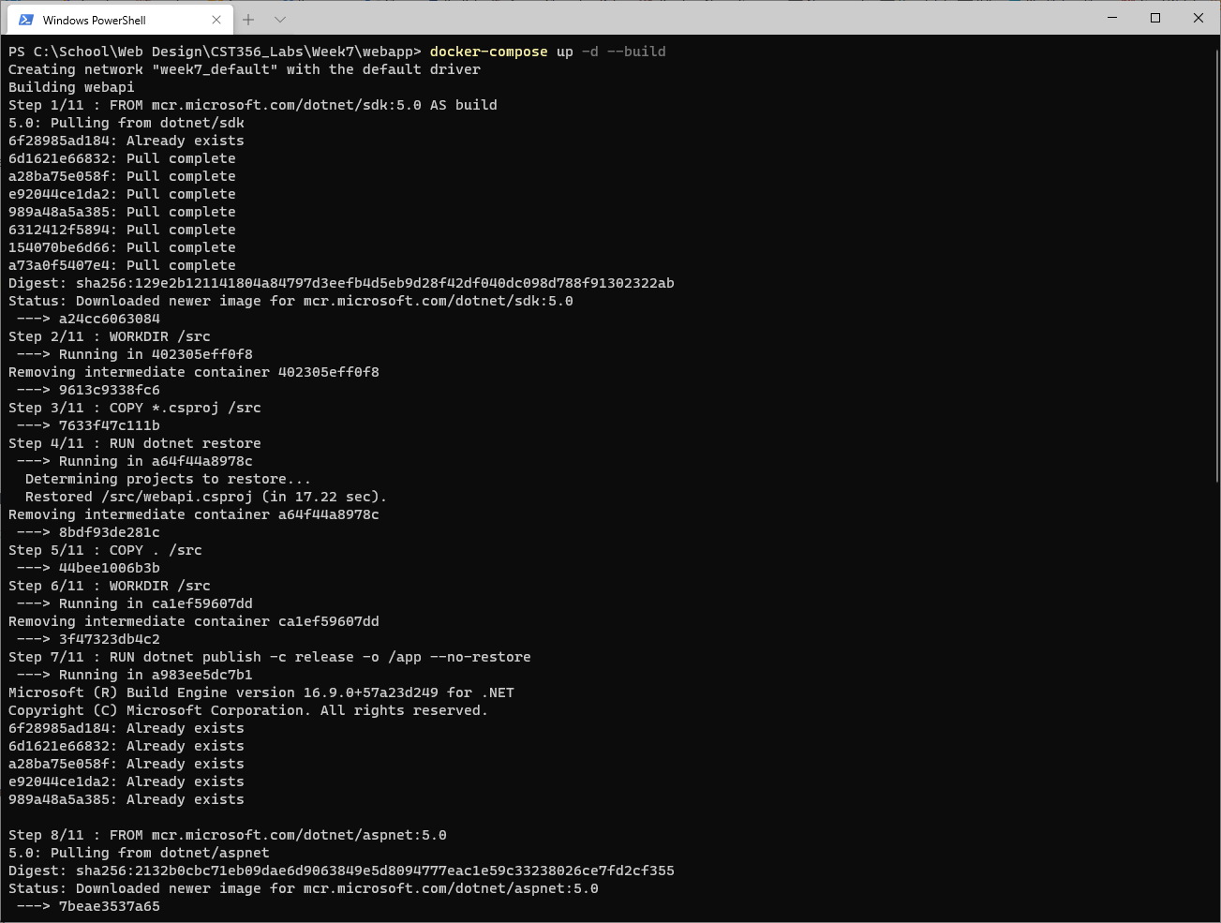

Exercise 4, part 7 – Docker build cont

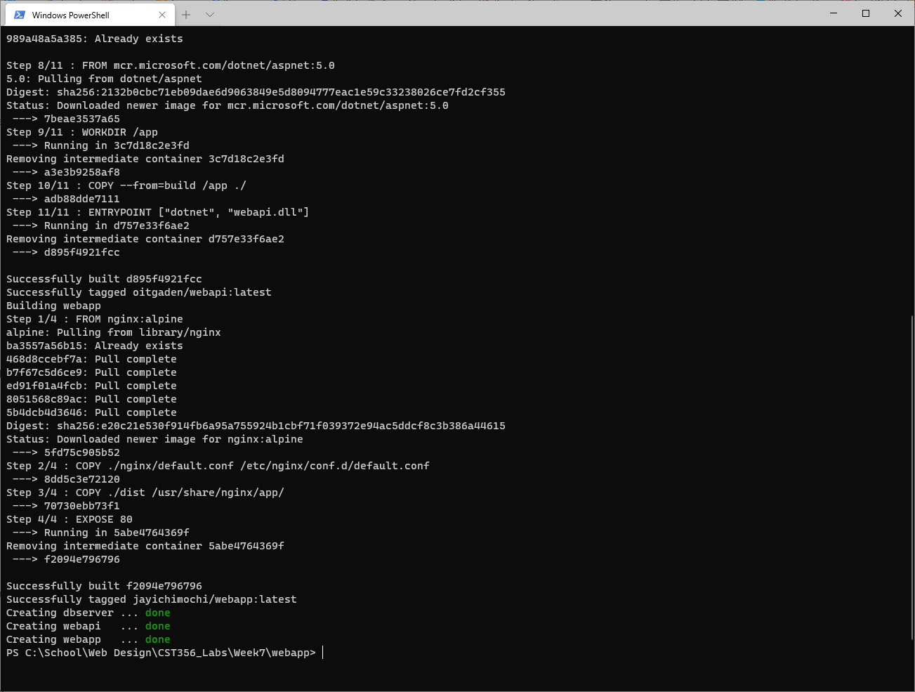

Exercise 4, part 7 – docker ps

